

Submitted By:
Muhammad Ahmed Subhani
SU92 – BSSEM – S25 – 018
Section: 4-A

Submitted To:
Mrs. Momna Naseem

Department of Software Engineering
Superior University, Lahore
TASK 1
Program:
#include <iostream>
using namespace std;

struct Node{
int data;
Node* next;
};
int main() {
Node* head = NULL;
Node* current = NULL;
for(int i=1; i<=5; i++){
Node* newnode = new Node;
newnode -> data = i* 10;
newnode -> next = NULL;
if(head == NULL){
head = newnode;
current = newnode;
}
else {
current->next = newnode;
current = newnode;
}
}
current = head;
while(current != NULL){
cout << current -> data << " ";
cout <<"next address: " << current -> next << endl;
current = current -> next;
}

}

Output:
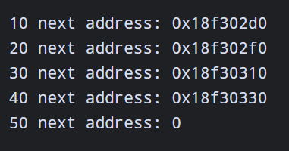
Task 2
Program:

#include <iostream>
using namespace std;

struct Node{
int data;
Node* next;
};
int main() {

Node* head = new Node;
Node* second = new Node;

head -> data = 50;
head -> next = second;

second -> data = 100;
second -> next = NULL;

Node* newnode = new Node;
newnode -> data = 150;

newnode -> next = head;
head = newnode;

Node* current = head;
while (current != NULL) {
cout << "Data: " << current -> data << endl;
cout << "Next: " << current -> next << endl;

current = current -> next;
}
}

Output:
